WebMarkup Assessment guide

Contact Examiner:

Name : Mr. Micha van der Meer BEc, MSc

EMAIL : [micha.vandermeer@inholland.nl](mailto:micha.vandermeer@inholland.nl)

V208

B1 20/21

Table of contents

Storyline 2

Roadmap 2

Website framework (must haves) 3

index.html 4

howsolarworks.html 7

eusolar.html 10

contact.html 12

CSS 15

Grading reference 15

Grading 16

Group one [BASIC HTML] 16

Group two [ADVANCED HTML] 17

Group THREE [BASIC CSS] 18

Group FOUR [ADVANCED CSS] 19

Group FIVE [SymantEc fundAmentals] 20

Deliverables 21

Running website with the total assessment 21

Access to your repository. 21

Deadline 21

Appendix A: 22

# Storyline

Mr. Frederik Harrems is a successful insurance specialist from Purmerend. During his evening meal he was discussing global warming problems with his wife. They question themselves what they could do back for the next generation. After doing research, they decided in 2007 to quit their job and help make the world a better place. They started a company called “Harrems Zonnepanelen” and helped other people to install solar power.

Now it’s your turn to move human beings from fossil fuels to solar power! The Netherlands is one the countries with the lowest Solar energy revenues compared to other countries. You can start the movement and sometimes one person can make the difference.

Mr. Frederik Harrems did some research for you already and pre-selected quality products.

If you use content from the owners please ask the owners for permission.

# Roadmap

To finish the assessment in the right way, follow precisely the next steps.

* Create the webpage according to the chapter “**WEBSITE FRAMEWORK**” in this document.
* Double check everything if you did not miss something according to the chapter “**GRADING REFERENCE**” in this document. If you have any questions do not hesitate to contact the examiner from the assessment (contact details on the cover page).
* Commit your work according to the chapter “**DELIVERABLES**” and “**Deadline**” in this document.

Success with the assessment!

# Website framework (must haves)

The http://i-want-solar-energy.com website have 4 html pages. Every page has its own properties

index.html landings page with articles and product information

howsolarworks.html building blocks how solar works.

eusolar.html table with information about solar use per country

contact.html contact form

Under you will find the details from every page. If one of the items from the webpages is not delivered, the assessment will have an automatic FAILED (1.0) rating (10 points).

## index.html

The landing page is called index.html in lowercase.

1. Website header
   1. Website logo.
   2. Use <h1> tag, for the title. Example “InHolland solar energy”.
   3. Use <h2> tag for the payoff . Example “Make the world a better place”.
2. Navigation
   1. Use a <nav> tag.
   2. Use <ul>, <li> tags to create the menu.
   3. <li> tag referring to:
      1. howsolarworks.html
      2. eusolar.html
      3. contact.html
   4. Mobile website is using a hamburger menu with only html and css.
3. Promotion movie about solar energy.
   1. For PC, tablet max 50 mb .
   2. For mobile max 20mb.
   3. Movie supports mp4 and ogg.
   4. Movie controls are hidden.
4. 3 Articles with 3 different solar products.
   1. Choose 3 different product from Appendix A .
   2. Use at least section, article, header, footer and p tags.
   3. Write a story about every product (70 – 100 words per product).
   4. Use 1 images (photo) per product and do not forget to add copyright info.
   5. Add a text for example “more info” or “order product” with a hyperlink to the “shop link” delivered in Appendix A.
   6. Add a hyperlink from the image to the “shop link” delivered in Appendix A.
   7. Align the image to the article:
      1. PC : floating to the right.
      2. Tablet : floating to the left.
      3. Mobile : under the article and image is centered with margin.
5. Aside : with 5 reasons.
   1. Make an order list with 5 reasons why to use solar power.
   2. Max 10 words per reason.
   3. The aside is fixed and can’t grow or shrink.
6. Footer
   1. Use copyright sign as entity and author info (student name)
7. Cookie statement.
   1. Make a **fixed** box with the text “Cookie statement” color #FFF.
   2. Opacity from the box is 50% with color #FA0.
8. The index.html is done with a flex-box layout module .

index.html have the following element ratios and breakdown.

**PC version index.html**

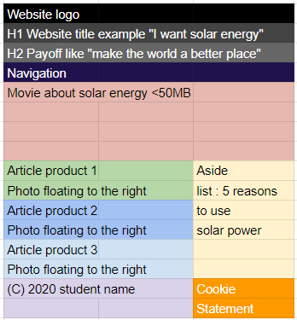

**Tablet version index.html**

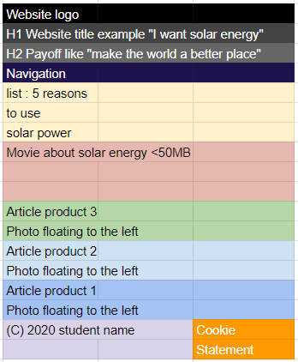

**Mobile version index.html**

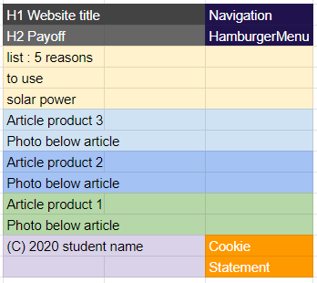

## howsolarworks.html

The howsolorworks.html in lowercase. This page explains how the light is converted into electricity. Solar panels are collecting photons of the sunlight. The electric current is handled by the charge controller and will load the battery system. The electricity produced at this stage is DC (direct current) and must be converted to AC (alternating current).

1. Website header
   1. Website logo.
   2. Use <h1> tag, for the title. Example “InHolland solar energy”.
   3. Use <h2> tag for the payoff . Example “Make the world a better place”.
2. Navigation
   1. Use a <nav> tag.
   2. Use <ul>, <li> tags to create the menu.
   3. <li> tag referring to:
      1. index.html (home)
      2. eusolar.html
      3. contact.html
   4. Mobile website is using a hamburger menu with only html and css.
3. Article 1 : Solar panels
   1. Write a story about solar panels (70 – 100 words per product).
4. Article 2 : Charge controller
   1. Write a story about a charge controller (70 – 100 words per product).
5. Article 3 : Battery system
   1. Write a story about the battery system (70 – 100 words per product).
6. Article 4 : DC power
   1. Write a story about DC (direct current) (70 – 100 words per product).
7. Article 5 : Inverter
   1. Write a story about Inverter (70 – 100 words per product).
8. Article 6 : AC power
   1. Write a story about AC (alternating current)(70 – 100 words per product).
9. Aside : 3 Products.
   1. Use the image from 3 products to push traffic to https://www.ikwilzonneenergie.nl/
10. Footer
    1. Use copyright sign as entity and author info (student name)
11. Cookie statement.
    1. Make a **fixed** box with the text “Cookie statement” color #FFF.
    2. Opacity from the box is 50% with color #FA0.
12. The howsolarworks.html is done with a grid layout module .

howsolarworks.html have the following element ratios and breakdown.

**PC version howsolorworks.html**

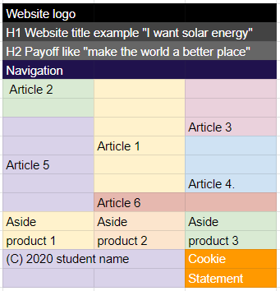

**Tablet version howsolorworks.html**

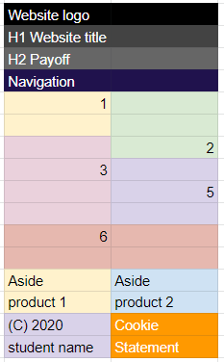

**Mobile version howsolorworks.html**

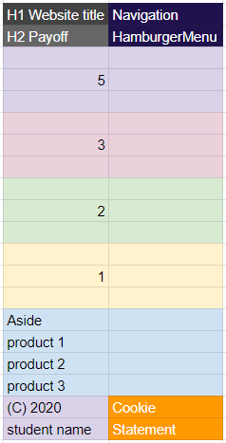

## eusolar.html

The eusolar.html in lowercase. This page provides insight into how much solar energy is generated in Europe per country.

1. Website header
   1. Website logo.
   2. Use <h1> tag, for the title. Example “InHolland solar energy”.
   3. Use <h2> tag for the payoff . Example “Make the world a better place”.
2. Navigation
   1. Use a <nav> tag.
   2. Use <ul>, <li> tags to create the menu.
   3. <li> tag referring to:
      1. index.html (home)
      2. howsolarworks.html
      3. contact.html
   4. Mobile website is using a hamburger menu with only html and css.
3. Table with Solar data per country.
   1. Convert the “Solar_energie_eu.xls” to a table in HTML
   2. Add a copyright info below the table “Source of data © 2020 Eurostat”.
4. Aside : 3 Products.
   1. Use the image from 3 products to push traffic to https://www.ikwilzonneenergie.nl/
5. Footer
   1. Use copyright sign as entity and author info (student name)
6. Cookie statement.
   1. Make a **fixed** box with the text “Cookie statement” color #FFF.
   2. Opacity from the box is 50% with color #FA0.

eusolar.html have the following element ratios and breakdown.

**PC version eusolar.html**

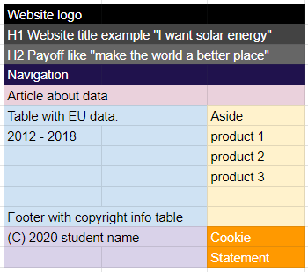

**Tablet version eusolar.html**

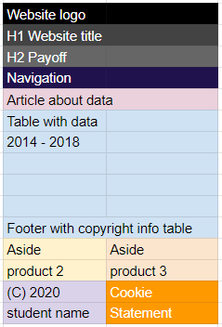

**Mobile version eusolar.html**

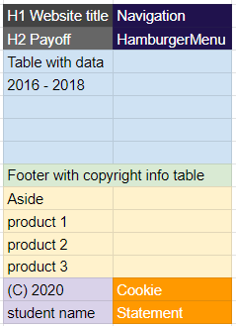

## contact.html

The contact.html in lowercase. This page is the contact page.

1. Website header
   1. Website logo.
   2. Use <h1> tag, for the title. Example “InHolland solar energy”.
   3. Use <h2> tag for the payoff . Example “Make the world a better place”.
2. Navigation
   1. Use a <nav> tag.
   2. Use <ul>, <li> tags to create the menu.
   3. <li> tag referring to:
      1. index.html (home)
      2. howsolarworks.html
      3. eusolar.html
   4. Mobile website is using a hamburger menu with only html and css.
3. Contact form
   1. The website visitor can leave a question. The following field are required: visitor name, visitor email and visitor message.
   2. Use action="http:// i-want-solar-energy.com/testform.php" (also for testing)
   3. Use for visitor name -> attribute, name="name"
   4. Use for visitor email -> attribute, name="email"
   5. Use for visitor message -> attribute, name="message"
   6. Use the tag fieldset.
   7. Use the tag legend
4. Aside : 3 Products.
   1. Use the image from 3 products to push traffic to https://www.ikwilzonneenergie.nl/
5. Footer
   1. Use copyright sign as entity and author info (student name)
6. Cookie statement.
   1. Make a **fixed** box with the text “Cookie statement” color #FFF.
   2. Opacity from the box is 50% with color #FA0.

contact.html have the following element ratios and breakdown.

**PC version contact.html**

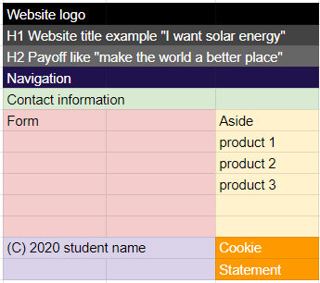

**Tablet version contact.html**

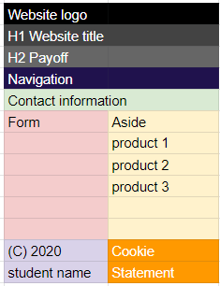

**Mobile version contact.html**

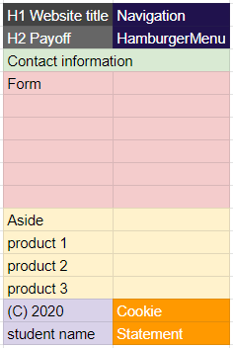

## CSS

The style.css is acting differently on PC, Tablet and Mobile devices. The website is responsive.

**!** All rules and lessons learned at the lecture “web design” and “Web Mark-up” are applicable to the design of the webpage.

The final webpage will be tested on:

* + - Chrome 85 (Feb 2020) or higher version
    - Firefox 81 (Sept 2020) or higher version
    - Edge 85 (Aug 2020) or higher version

Web browser timeline:

https://en.wikipedia.org/wiki/Timeline_of_web_browsers

Definition of devices is described in the “test devices definition” table:

|  |  |  |
| --- | --- | --- |
| TEST Devices definition | | |
|  | CSS width | expected pixel ratio |
| PC | >1280px | 1 |
| Mobile | <480px | 3 |
| Tablet | 481px – 1179px | 2 |

# Grading reference

The grading is done by a grading matrix.

The assignment has 5 rating groups.

|  |  |
| --- | --- |
| Group |  |
| 1 | Basic HTML |
| 2 | Advanced HTML |
| 3 | Basic CSS |
| 4 | Advanced CSS |
| 5 | Symantec fundamentals |

The total score for the assessment is 100 points. Every group can be graded with insufficient, sufficient and excellent. The highest score in the group counts. To get the points for excellent, it is mandatory to achieve all the features of sufficient.

* Insufficient counts for 1 point
* Sufficient counts for 11 points
* Excellent counts for 20 points.

The total of the 5 groups must be 55 points or higher to succeed for this course!

# Grading

How to calculate the grading can be found in the chapter “**GRADING REFERENCE**” in this document. All items in a group must be met in order to obtain the grade of the group. If one or more items from sufficient is mist the group sufficient will be graded as insufficient.

### Group one [BASIC HTML]

Excellent

* All items from sufficient are passed.
* Is **not** using embedded style.
* Is **not** using inline style.
* Uses all entities right ©,®,™, &,",£,€ etc.
* Uses img folder for all images.
* Uses alt attributes for all images.
* Uses title attributes for all images.
* Uses figcaption element.
* Uses figure element.
* Uses table tag.
* Uses table head.

Sufficient

* Uses HTML5 doctype.
* Uses head tag.
* Uses page title element.
* Uses body tag.
* Uses h1 element.
* Uses h2 element.
* Uses paragraph element
* Uses copyright info in the footer.
* Uses an anchor element.
* Uses img element with an image.
* Uses ordered list.
* Uses an unordered list.

### Group two [ADVANCED HTML]

Excellent

* All items from sufficient are passed.
* Uses type attribute with value "text/css" for the stylesheet.
* Uses favicon.
* Uses "css" folder (lowercase).
* Uses the right extension for stylesheets (lowercase).
* Uses strong tag.
* Uses 2 different formats for video (MP4 and OGG).
* Uses a label tag in the form.
* Uses legend tag in the form.
* Uses input tag with attribute type and value email.
* Uses input tag with attribute type and value submit.

Sufficient

* Is **not** using tag div.
* Uses link attribute with value "stylesheet" for the stylesheet.
* Uses location attribute with an URL value for the stylesheet.
* Uses section tag.
* Uses header tag.
* Uses article tag.
* Uses aside tag.
* Uses nav tag.
* Uses footer tag.
* Uses form tag.
* Uses em tag.

### Group THREE [BASIC CSS]

Excellent

* All items from sufficient are passed.
* Uses font family "Notable", designed by Eli Block, Hana Tanimura, Noemie Le Coz from Google fonts.
* Uses print color Pantome 123C with CMYK property. (Color in RGB is #FFC72B)
* Uses property text-transform in uppercase.
* Uses relative units in css (em, rem).
* Uses the property font-family with value "Arial", "Helvetica" and "sans-serif" as default font for the body tag.
* Uses the property font-family with value Notable.

Sufficient

* Design is Responsive.
* Uses absolute units in css (px).
* Uses at least 7 different color properties in hexadecimal.
* Uses at least one comment in CSS.
* Uses property letter-spacing.
* Uses property line-height.
* Uses property word-indent.
* Uses property word-spacing.

### Group FOUR [ADVANCED CSS]

Excellent

* All items from sufficient are passed.
* Uses at least 2 position properties (static, absolute, relative or fixed).
* Uses float property.
* Uses pseudo-class first-child to color the first column #FF0 from a table.
* Uses pseudo-class nth-child to color the even horizontal lines the background color #CFF and odd lines #FFF from a table.
* Uses pseudo-element first-letter.
* Uses selecting elements by a + (plus).
* Uses selecting elements by a > (bigger sign).

Sufficient

* Is **not** using property value !important.
* Uses pseudo-class mouse over link.
* Uses pseudo-class selected link.
* Uses selecting elements by , (comma).
* Uses selecting elements by a space.
* Uses the property border-color.
* Uses the property border-style with value double.
* Uses the property border-width.

### Group FIVE [SymantEc fundAmentals]

Excellent

* All items from sufficient are passed.
* Uses media queries for at least 3 different devices.
* Uses closing tags for all single and paired tags in the right way.
* Uses description attribute value with 50–160 characters.
* Uses keywords attribute with 5 keywords.
* Uses language attribute.
* Uses flex-grow property.
* Uses flex-shrink property.
* Uses grid-template-areas property.
* CSS is validated with http://jigsaw.w3.org/css-validator, with profile "CSS level 3 + SVG" without warnings.
* HTML 5 is validated with https://validator.w3.org without warnings.

Sufficient

* Is **not** using front-end libraries like bootstrap, w3.css etc.
* Is **not** using tag br.
* Is **not** using tag hr.
* Uses attribute charset utf-8.
* Uses author attribute value .
* Uses property z-index for a "cookies" message with value 9999.
* Uses tabs for nestled elements.
* Uses the property display to hide content for different devices.
* CSS is validated with http://jigsaw.w3.org/css-validator, with profile "CSS level 3 + SVG" without errors.
* HTML 5 is validated with https://validator.w3.org without errors.

# Deliverables

You can only commit your final work on i-want-solar-energy.com server. We do not accept any files for security reasons. Please do not email the examiner with your URL, we do know your URL.

One day after the deadline the examiner will make a backup from all the work on the

i-want-solar-energy.com server. Do not copy source code from the internet or snippets from your colleagues students. The delivered work will be screened on plagiarism by a machine learning system!

Expected work:

## Running website with the total assessment

* Copy the files in /httpdocs on the FTP server!
* Test if **i-want-solar-energy.com/studentnumber/index.html** is working.
* Other requested pages from the assessment are accessible.
* The **student.txt** is delivered by the examiner on Moodle. The **student.txt** is placed in the root from the website. The **student.txt i**s completed with
  + Student name: your name
  + Student number: your student number
  + Student class: your class
  + URL student GitHub repository: your GitHub URL

## Access to your repository.

* Only GitHub (<https://github.com/>) is allowed to use.
* In between commitments (versions before the final) must be accessible.
* The **first commit** must be the delivered student.txt.
* Private repositories are not allowed. Repositories are publicly accessible without any login.

If above is not delivered, the assessment will have an automatic FAILED (1.0) rating.

# Deadline

8 November 2020 23:59

Retake: 9 January 2021 23:59

# Appendix A:

Product : Victron SmartSolar MPPT 100-50 12V 24V charge controller

Shop link : <http://www.ikwilzonneenergie.nl/Victron-SmartSolar-MPPT-100-50-12V-24V>

Product description : <https://www.victronenergy.com/solar-charge-controllers/smartsolar-100-30-100-50>

Product : Victron SmartSolar MPPT 150-35 12V 24V 48V charge controller

Shop link : <http://www.ikwilzonneenergie.nl/Victron-SmartSolar-MPPT-150-35-12V-24V-48V>

Product description : <https://www.victronenergy.com/solar-charge-controllers/smartsolar-150-35>

Product : SMA SB3.6 Solar panels inverter 1 phase

Shop link : <http://www.ikwilzonneenergie.nl/SMA-Sunny-Boy-SB36-omvormer>

Product description : <https://www.sma.de/en/products/solarinverters/sunny-boy-30-36-40-50-60.html>

Product : SMA STP8.0 Solar panels inverter 3-phases

Shop link : <http://www.ikwilzonneenergie.nl/SMA-Omvormer-STP-80-3AV-40>

Product description : <https://www.sma.de/en/products/solarinverters/sunny-tripower-80-100.html>

Product : Victron 175Wp 12Volt Solar panel set

Shop link : <http://www.ikwilzonneenergie.nl/175Wp-12Volt-zonne-energie-set>

Product description : <https://www.steca.com/index.php?Steca-Solarix-en>

Product : Victron Smart inverter 12V 2000W 230V~

Shop link : <http://www.ikwilzonneenergie.nl/Victron-Energy-omvormer-smart-12V-2000W-230V>

Product description : <https://www.victronenergy.com/inverters/phoenix-inverter-smart>

Product : Victron AGM Super Cycle battery 12V 100Ah

Shop link : <http://www.ikwilzonneenergie.nl/Victron-AGM-Super-Cycle-accu-12V-100Ah>

Product description : <https://www.victronenergy.com/batteries/gel-and-agm-batteries>

Product : Victron Phoenix inverter 12V 1200W VE.Direct

Shop link : <http://www.ikwilzonneenergie.nl/Victron-Phoenix-omvormer-12V-1200Watt>

Product description : <https://www.victronenergy.com/inverters/phoenix-inverter-vedirect-250va-800va>

Product : Victron MultiPlus 12/3000/120-16 230V VE.Bus

Shop link : <http://www.ikwilzonneenergie.nl/Victron-Energy-Multiplus-12V/3000W/120-16>

Product description : <https://www.victronenergy.com/inverters-chargers/multiplus-12v-24v-48v-800va-3kva>

Product : EasySolar 24/3000/70-50 MPPT 150/70 230V~ with color control

Shop link : <http://www.ikwilzonneenergie.nl/Victron-EasySolar-24V-3000W-70A-50-MPPT-Color-Control>

Product description : <https://www.victronenergy.com/inverters-chargers/easysolar>